Final Executed Results:
Login:
The final results of my project are as follows:
- The desired ADMIN input to validate the application the username: naga and password: naga
  - 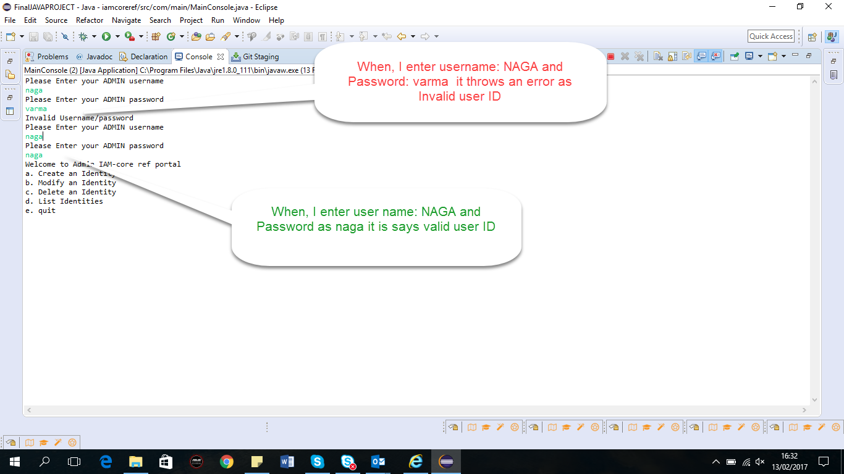
- Create Identity:
- I have created 5 Identities and listed all those 5 Identities
  - 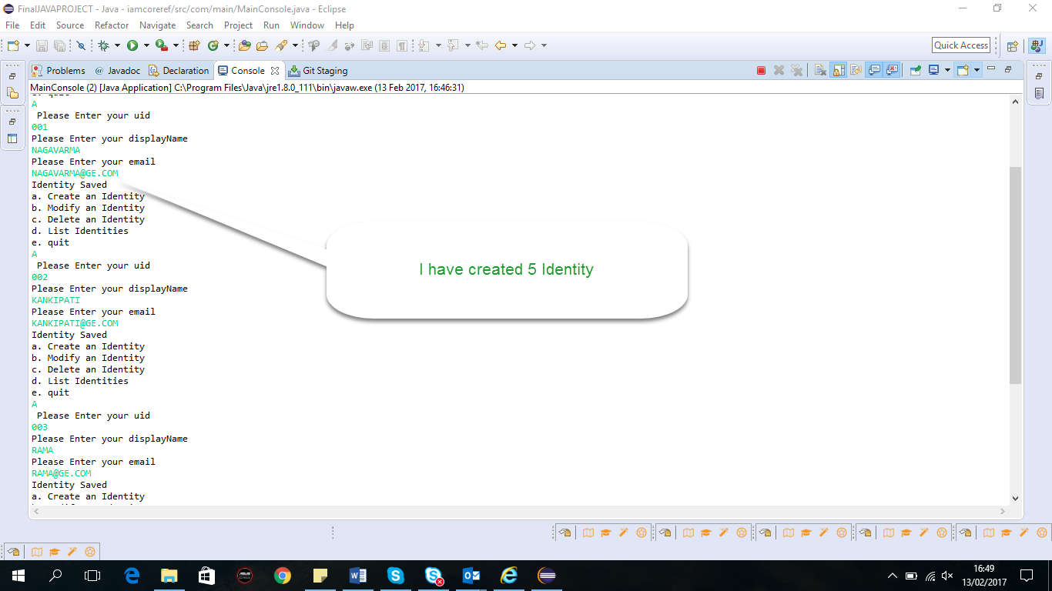

- List Identity:
  - 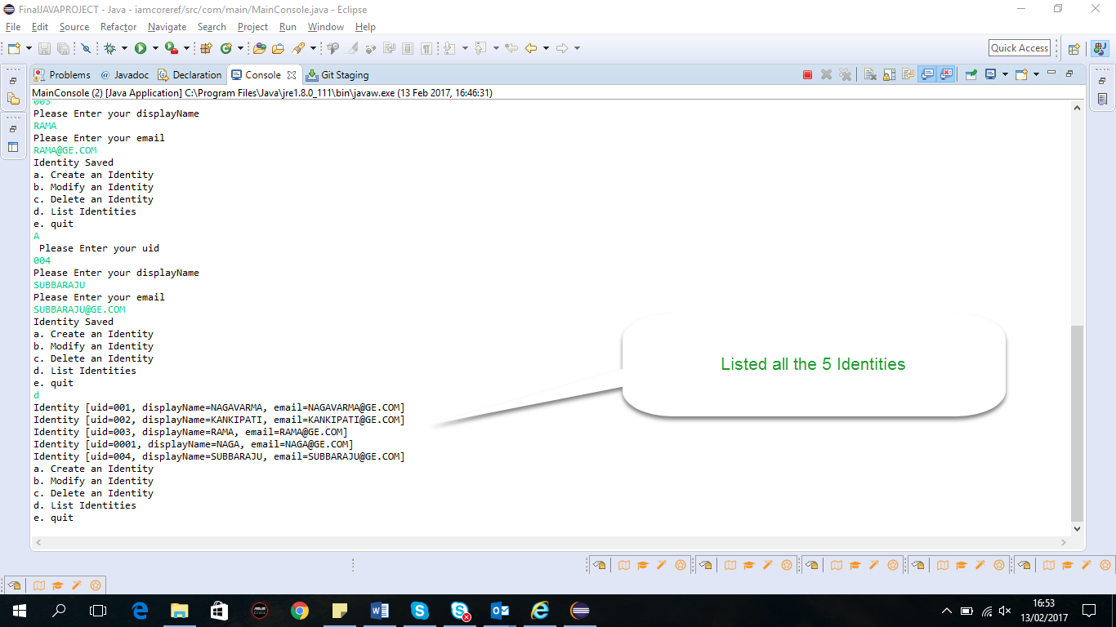
- Modify Identity:
- I have modified 1 Identity and listed it
  - 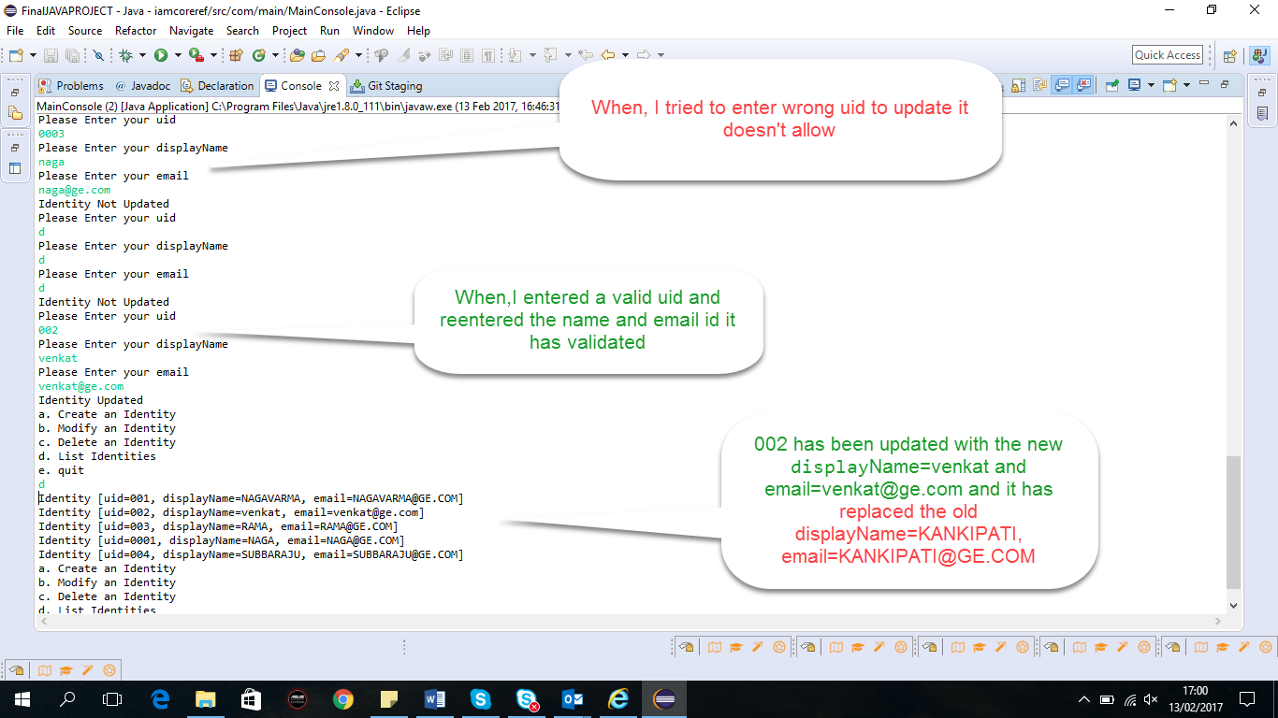

- Delete Identity:
- I have used delete identity and have successfully deleted 002 and 0001 identities
  - 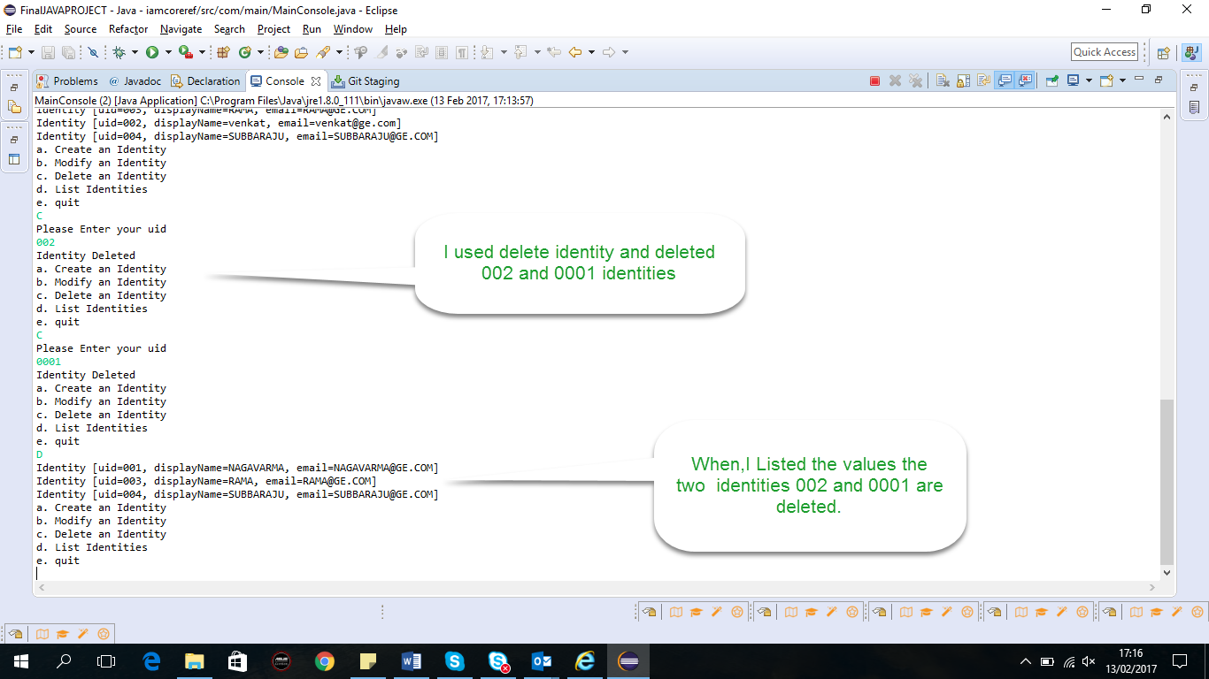
- Logout Identity:
- I have used quit option and have successfully ended the application
  - 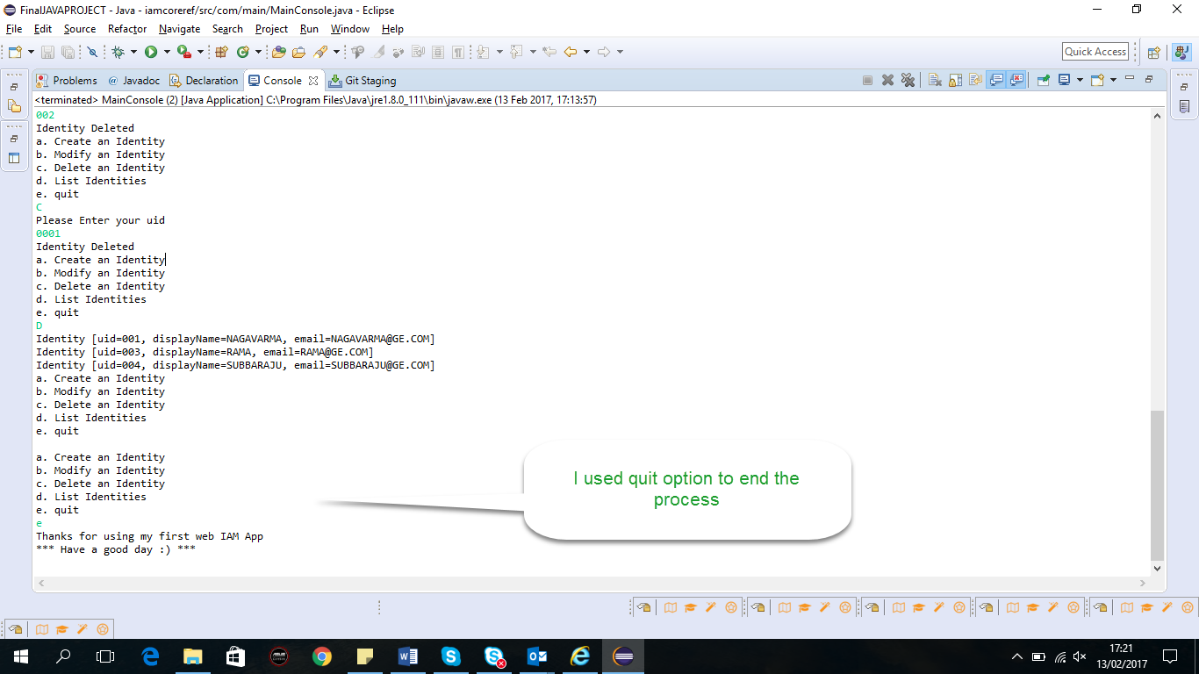

- Final output is updated in the database:

- 